1. **Create a virtual environment and install django in it - attach a screen shot**

**Created virtual environment**

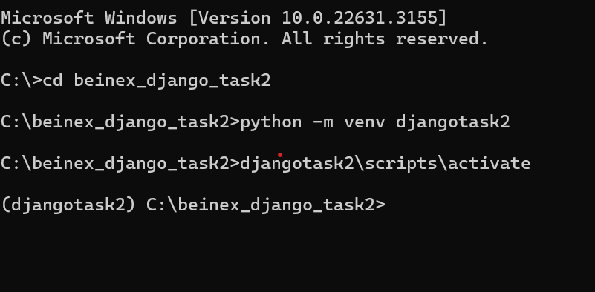

**Install Django**

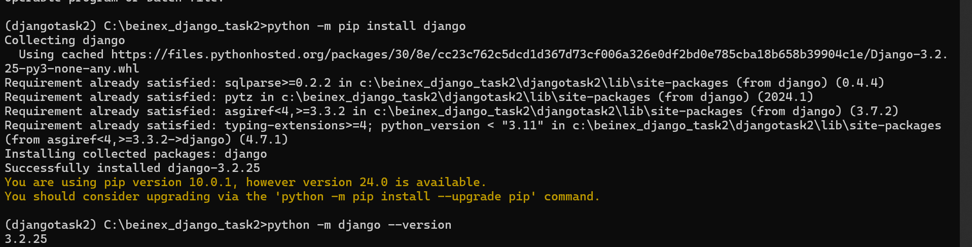

1. **Create a django project and app , explain the files of the project and app folders**

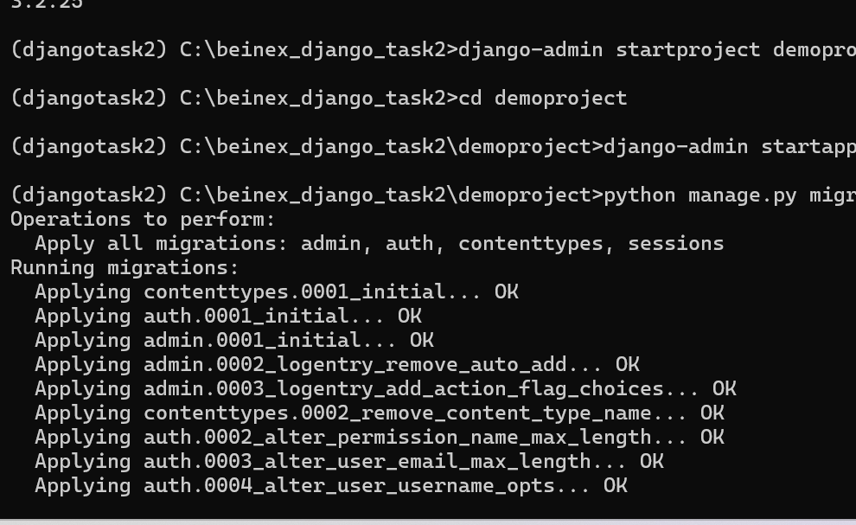

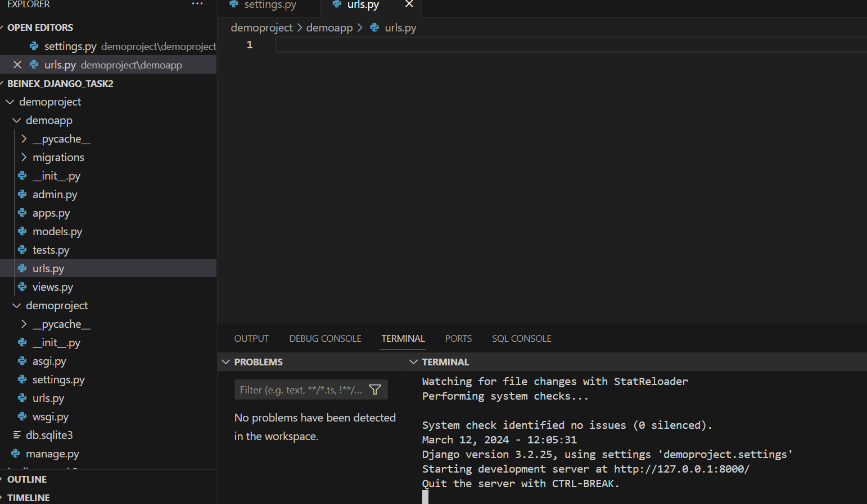

**Project**

**__init__.py :** The **__init__.py** file is a special Python file that indicates to the Python interpreter that the directory should be treated as a package. It can be empty or contain initialization code for the package.

**Asgi.py : asgi.py** is a Python file commonly found in Django projects. It stands for Asynchronous Server Gateway Interface (ASGI), which is a standard interface between Python asynchronous web servers and Python web applications or frameworks.

**Settings.py:** The **settings.py** file is a central configuration file in Django projects. It contains various settings that configure the behavior of your Django project, including database settings, static files configuration, middleware, installed apps, and much more.

**Urls.py:** In a Django project, the **urls.py** file is a fundamental component responsible for routing incoming requests to the appropriate view functions or class-based views. It defines the URL patterns for your application, mapping URLs to views.

**Wsgi.py:** The **wsgi.py** file in a Django project is used to expose the WSGI (Web Server Gateway Interface) callable application object. WSGI is a standard interface between web servers and Python web applications or frameworks.

**APPS**

**__init__.py:** The **__init__.py** file is a special Python file that indicates to the Python interpreter that the directory should be treated as a package. It can be empty or contain initialization code for the package.

**Admin.py :** The **admin.py** file in a Django application is where you register models to make them available in the Django admin interface. The Django admin is a powerful tool that automatically generates a web-based interface for managing your site's data.

**Apps.py:** The **apps.py** file is typically found within each Django app and is used to define the configuration of that particular app. It's where you can customize various aspects of your app, such as its display name, verbose name, application configuration, and more.

**Test.py:** The **test.py** file in a Django app is where you can write tests for your application. Testing is a crucial aspect of software development, ensuring that your code behaves as expected and continues to work correctly as you make changes or add new features.

**Models.py:** In a Django application, the **models.py** file is where you define the structure of your database tables using Django's Object-Relational Mapping (ORM) system. Each model class represents a database table, and each attribute of the class represents a field in that table.

**Views.py :** In a Django application, the **views.py** file is where you define the logic for handling incoming HTTP requests and returning HTTP responses. Views are the heart of your web application, as they determine what content is displayed to the user and how it's presented.

1. **Run the django project - attach screen shots of the django admin panel and SITE.**

